Hands on Casestudy for Selenium

You work as a Devops Engineer in Ventura Soft Pvt Ltd. Recently a new product has been released by the company which demands creating of test cases from scratch. This product is a search engine. You being new in the team have been asked to present a POC for your skills. Assume the search engine is bing.com, search on Bing for the term "intellipaat", and print the title of the search webpage in the console.

This test case should be packaged, and should run on AWS.

Steps

1. To perform the above action, we need to install eclipse inorder to write the selenium code, Eclipse JAVA EE version is installed
2. Create a Maven project in eclipse and define the porn.xml with the setting required to run selenium and Testng
3. Please see the attached xml for reference



1. Start writing the code to build the test case

**public** **class** App {

**private** WebDriver driver;

**public** **static** **void** main(String args[]) {

TestNG testSuite = **new** TestNG();

testSuite.setTestClasses(**new** Class[] { App.**class** });

//testSuite.addListener(new Test5SuiteListener());

testSuite.run();

}

@BeforeTest

**void** beforetest() {

//System.setProperty("webdriver.chrome.driver", "chromedriver.exe");

System.*setProperty*("webdriver.chrome.driver", "/home/ubuntu/chromedriver");

**final** ChromeOptions options = **new** ChromeOptions();

options.addArguments("headless");

driver = **new** ChromeDriver(options);

}

@BeforeMethod

**void** open() {

driver.get("https://www.bing.com/");

driver.manage().window().maximize();

}

@Test

**void** test() {

driver.findElement(By.*xpath*("//input[@id='sb_form_q']")).click();

driver.findElement(By.*xpath*("//input[@id='sb_form_q']")).sendKeys("intellipaat");

driver.findElement(By.*xpath*("//input[@id='sb_form_go']")).click();

driver.manage().timeouts().implicitlyWait(3, TimeUnit.***SECONDS***);

**final** String actualTitle = driver.getTitle();

**final** String expectedTitle = "intellipaat - Bing";

*assertEquals*(expectedTitle, actualTitle);

}

**static** **void** assertEquals(**final** String expectedTitle, **final** String actualTitle) {

**if** (expectedTitle.contentEquals(actualTitle))

System.***out***.println("success " + "actual title:" + actualTitle + " \n expected title: " + expectedTitle);

**else**

System.***out***.println("fail " + "actual title:" + actualTitle + " \n expected title: " + expectedTitle);

}

@AfterClass

**void** close() {

driver.quit();

}

}

1. Create a Runnable jar file and transfer the file to AWS instance

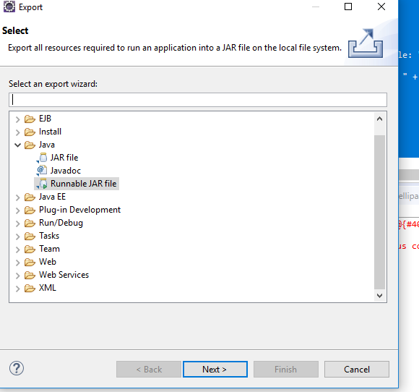

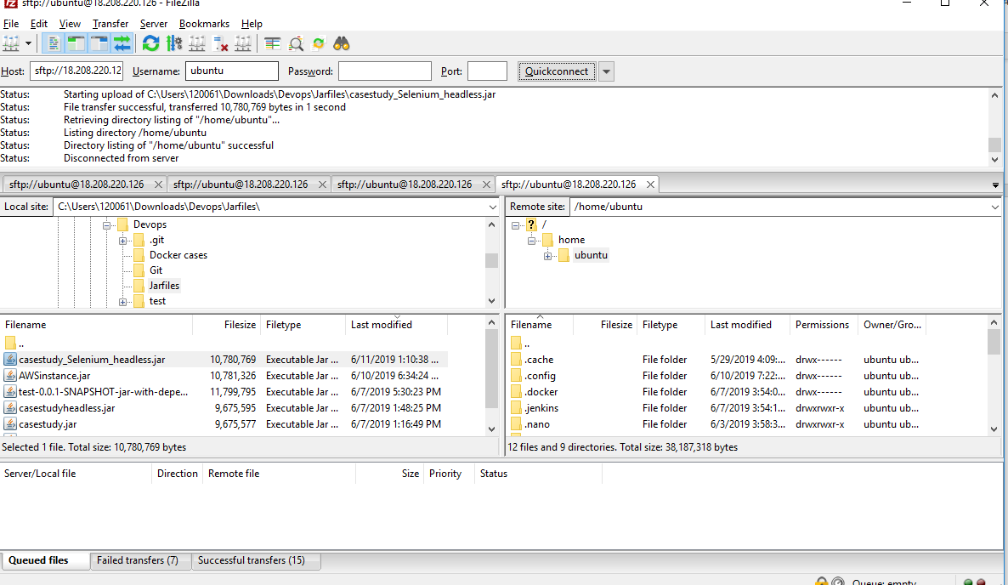

1. Now in the AWS instance, perform the below actions

Sudo apt-get update

sudo apt install openjdk-8-jdk

sudo apt install chromium-browser

1. Find the version of chrome browser and install the relevant linux driver in the AWS instance at /home/ubuntu

For installing the drivers—find the correct driven link and then perform wget link – where link is the location of driver

Then unzip the downloaded chrome driver

1. Now perform the action java -jar casestudy_Selenium_headless.jar, where the casestudy_Selenium_headless.jar is the package build using eclipse
2. Console must look this

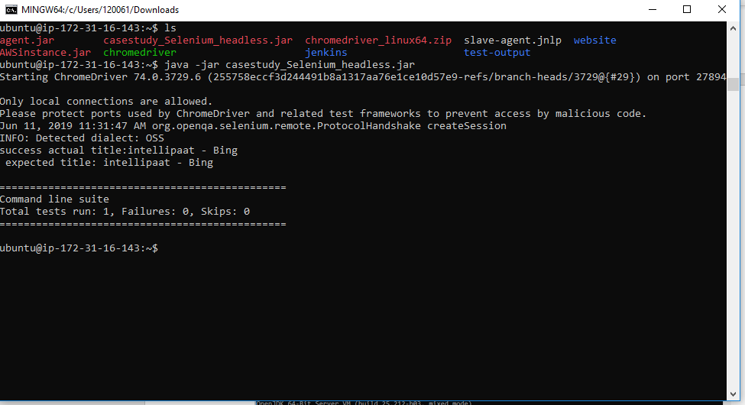

1. Please see the attached Jar file for reference

